Experiment : 6
Date:

USE CASE DIAGRAM

AIM:
The aim of this observation is to analyze the ATM cash withdrawal process using a use case diagram in software engineering. The goal is to understand user interactions with the system, identify functional requirements, and highlight the importance of modeling real-world scenarios.

INTRODUCTION :
In software engineering, use case diagrams are a powerful tool for representing system functionality from the user’s perspective. They help visualize the interactions between external actors (users) and the system, ensuring that requirements are captured clearly. The ATM system is a classic example where security, accuracy, and usability are critical. By modeling the cash withdrawal process, developers and stakeholders can better understand the workflow and design robust solutions.

DEFINITION:
- A use case diagram shows:
  - Actors: Users or external systems interacting with the system.
  - Use Cases: Functionalities or services the system provides.
  - Relationships: Connections between actors and use cases (e.g., include, extend).
It essentially answers the question: “who uses the system ,and what can they do with it?”

ACTORS INVOLVED:
- Customer/User – Initiates and performs withdrawal actions.
- ATM Machine – Provides the interface for user interaction.
- Bank Server/System – Validates credentials and processes transactions securely.

USE CASE DIAGRAM:

A Use Case Diagram is a type of behavioral diagram in Unified Modeling Language User Guide (UML) that visually represents how users (actors) interact with a system to achieve specific goals. It focuses on what the system does from the user's perspective rather than how it does it. By clearly identifying actors, use cases, and system boundaries, it provides a simple yet powerful way to capture functional requirements at a high level. It helps stakeholders understand system functionality without needing technical knowledge of implementation details.

Use case diagrams are especially important during the requirements gathering and analysis phase of the Software Development Life Cycle (SDLC). They support communication between developers, business analysts, and clients, reduce misunderstandings, and serve as a foundation for system design, testing, and documentation.

PURPOSE:

- To capture functional requirements of a system.
- To visualize user interactions with the system.
- To simplify communication between developers, business analysts, and stakeholders.
- To define system scope and boundaries clearly.
The diagram illustrates the sequence of actions a user performs to withdraw cash from an ATM.

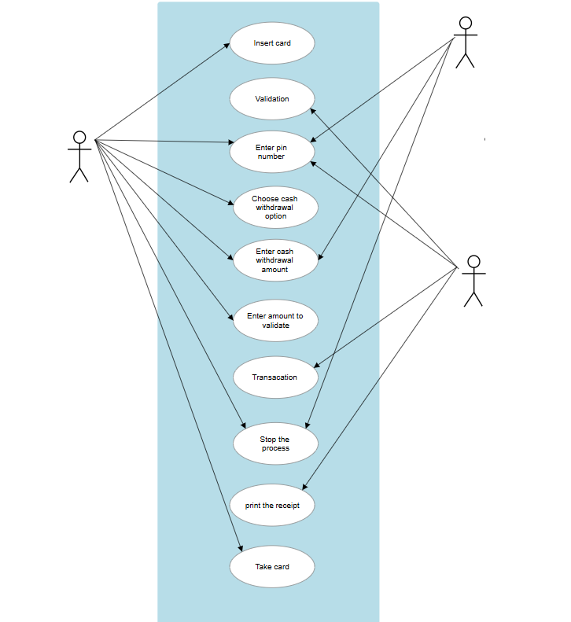

Steps in the process:
- Insert card
- Validation
- Enter PIN number
- Choose cash withdrawal option
- Enter withdrawal amount
- Validate amount
- Transaction execution
- Stop the process (optional exit)
- Print receipt
- Take card
This flow ensures that the transaction is secure, validated, and completed successfully.

OBSERVATION:

* The diagram emphasizes security checks (PIN validation, transaction validation).
*It includes optional flows (stop process, print receipt).
* It models end-to-end interaction, ensuring completeness.
*The system ensures user satisfaction by providing feedback (receipt, card return).

EXCEPTION HANDLING:

- If the PIN entered is incorrect, the system asks for re-entry and may block the card after multiple failed attempts.
- If the withdrawal amount exceeds the available balance, the system displays an error message.
- If the ATM runs out of cash or network fails, the transaction is cancelled automatically.
- If the user cancels the transaction midway, the ATM ejects the card safely.

ADVANTAGES:
- Clarity: Easy to understand for both developers and stakeholders.
- Requirement validation: Ensures all user actions are accounted for.
- Error reduction: Helps detect missing or redundant processes.
- Documentation: Serves as a reference throughout the software lifecycle.
- Stakeholder communication: Bridges the gap between business needs and technical design.

REAL WORLD EXAMPLES:
- Banking systems: ATM withdrawals, deposits, balance inquiries.
- E-commerce platforms: Checkout, payment, order tracking.
- Healthcare systems: Patient registration, appointment booking.
- Transportation: Online ticket booking, cancellation, and payment.

When to Use Case Diagrams:
- During requirement analysis
- Before system design
- When communicating with clients
- While identifying system actors
- During agile backlog creation
LIMITATIONS:
* Does not show internal logic
* No sequence of operations
* Cannot represent complex workflows
* Not suitable for detailed design

CONCLUSION:
The ATM cash withdrawal use case diagram demonstrates how software engineering tools can effectively capture real-world processes. By modeling user interactions, developers gain a clear understanding of system requirements, ensuring secure, efficient, and user-friendly software design.

